**DOM Introduction:**

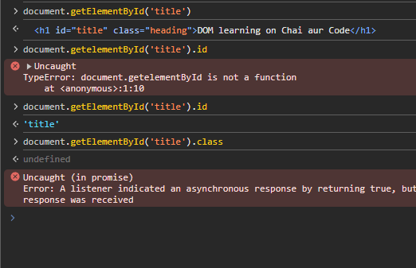

Class can’t be accessed by the above way.

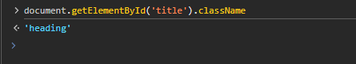

Attributes can be accessed.



getAttribute is a function

then,

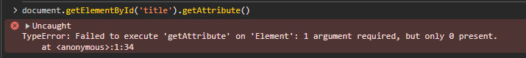

Need Argument:

 <= my mistake

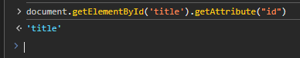



setAttribute() function



class attribute is overridden by ‘test’ value.



We can store it in a variable.

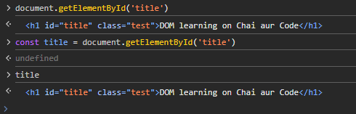

Style:

This is how we write in HTML, in a key value pair.

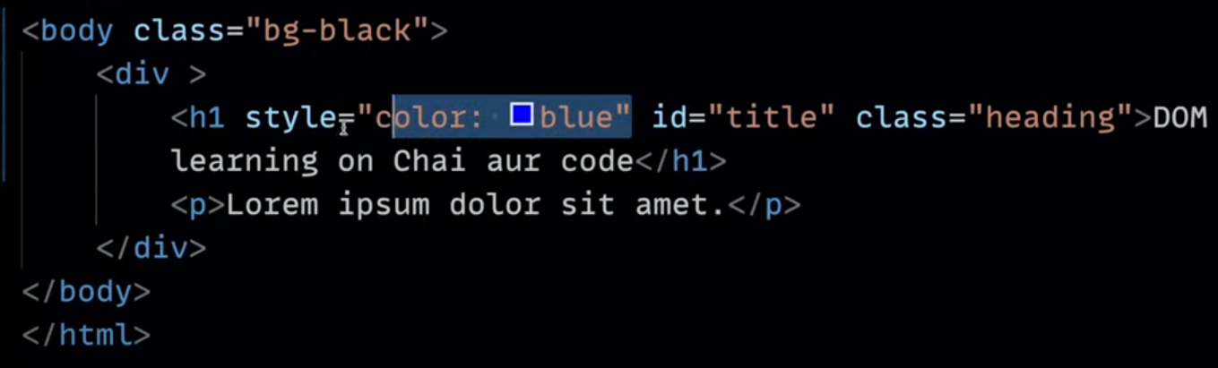

Doing it with DOM manipulation.

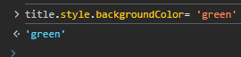

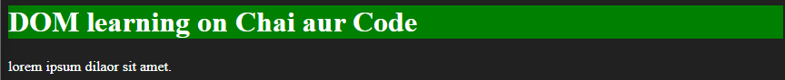

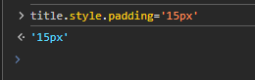



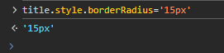



Due to above command how ‘title’ changed

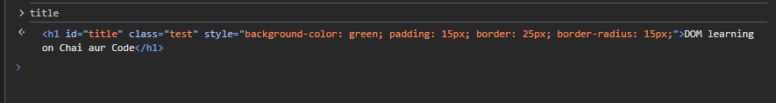

textContent vs innerHTML vs innerText:

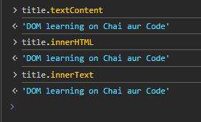

textContent vs innerText:

example:

adding span in HTML



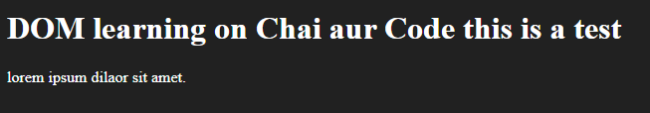

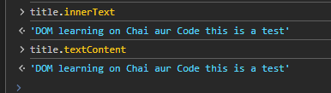

Style added to <span>



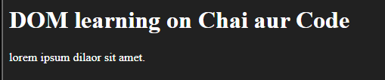

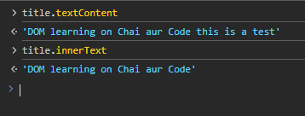

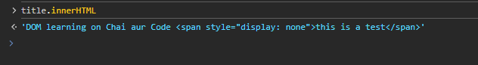

For the DOM:

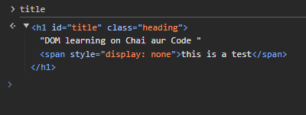

querySelector()

The Document method querySelector() returns the first Element within the document that matches the specified CSS selector, or group of CSS selectors. If no matches are found, null is returned.

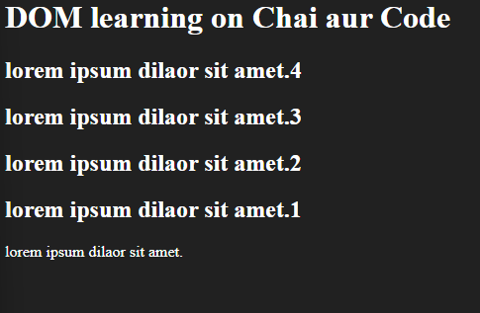

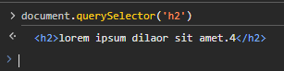

‘#’ for id AND ‘.’ for class

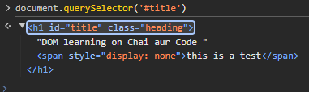

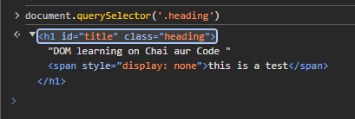

As of now we don’t have password input field in our HTML

So:

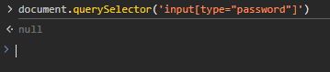

Let’s put one input field type =” password”

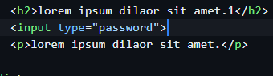

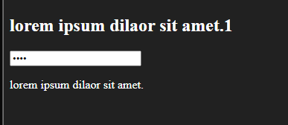

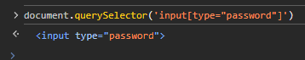

Some more things with querySelector()

Introduced an unordered list

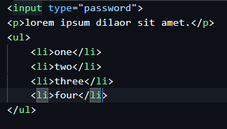

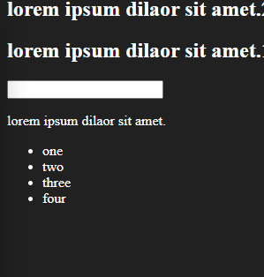

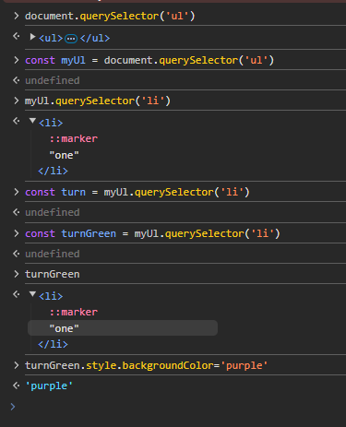

Above example represents using of querySelector one after one

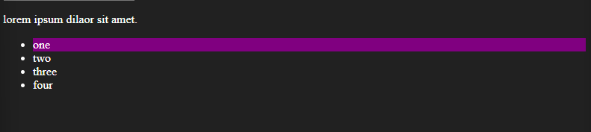

querySelectorAll()

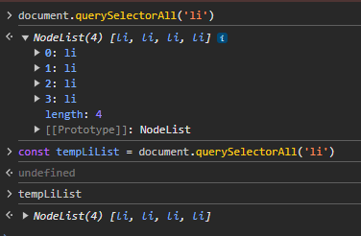

Working with NodeList

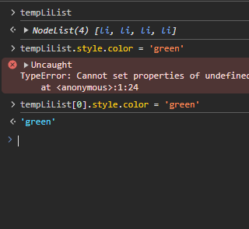 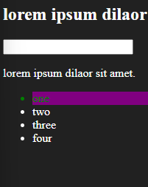

forEach() function:

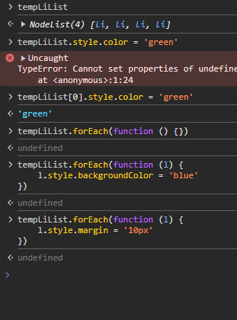

getElementsByClassName()

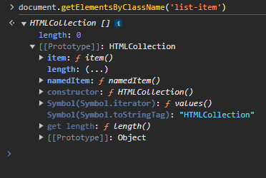

HTMLCollection()

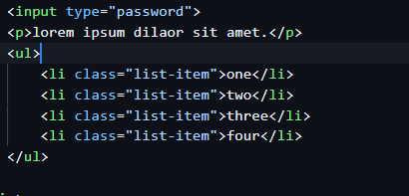

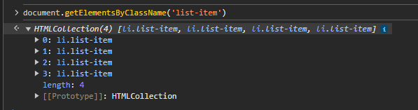

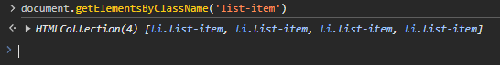

But How to loop on HTMLCollection , no forEach is present in prototype,

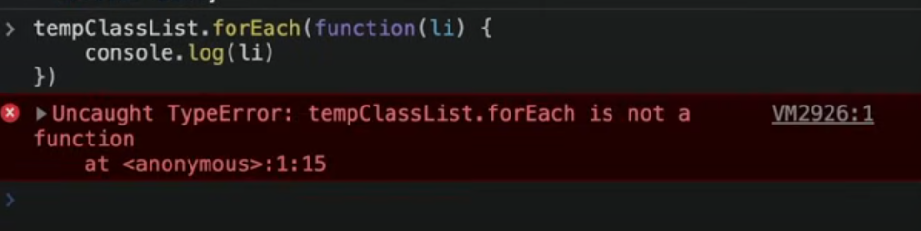

Take the help of array constructor, HTMLCollection will become array.

